

DEV SANSKRITI VISHWAVIDYALAYA

SESSION 2018-21

Lab Assignments
Of
Internet and
Web Technologies

Submitted To: Submitted By:
Mrs. Geetanjali Gaidhani Pranav Mishra
Lecturer BCA (5th Sem.)

Department of Computer Science,
DSVV, Haridwar
INDEX
S. No. | Task | Page No
1 | Create a student registration web page using HTML form objects. | 2
2 | Create a table having student information using HTML. | 4
3 | Explain following tags: <marquee>,<sup>,<pre>,<hr>,<iframe> with respective output. | 6
4 | Design a customer registration form for online shopping. | 12
5 | Create a simple HTML page having multiple frames. | 14
6 | Embed video in an HTML page. | 15
7 | Create a simple HTML page that uses inline CSS. | 16
8 | Create a simple HTML page that uses document level CSS. | 17
9 | Create an HTML page that uses external CSS. | 19
10 | Create an HTML page that uses all CSS Font properties. | 20
11 | Create an HTML page that uses all CSS Text properties. | 22
12 | Create an HTML page that uses all CSS Background Properties. | 24
13 | Create an HTML page that uses all CSS border properties. | 26
14 | Create an HTML page that uses all CSS List properties. | 27
15 | Create a CSS3 based zebra stripped table. | 29
16 | Create a four partition layout using CSS. | 31
17 | Create CSS3 based button. | 33
18 | Create an HTML page that uses all CSS Margin,Padding properties. | 34

1. Create a student registration web page using HTML form objects.

Code:

<!DOCTYPE html>
<html>
<head>
<title>Form Implementation</title>
</head>
<body>
<form>
First Name:- <input type="text" name="Firstname"><br>
Last Name :- <input type="text" name="Lastnamw"><br>
Date of Birth:- <input type ="date" name="date"><br>
email Id:-<input type="email" required name = "email"><br>
password:- <input type = "password" minlenght="6" name = "password"><br>
gender:- <br>
Male:- <input type= "radio" name="gender" value="male"><br>
Female:- <input type="radio" name="gender" value="female"><br>
Qualification:- <br>
<input type ="checkbox" name="Graduate">Graduate<br>
<input type ="checkbox" name ="Post graduate">post graduate<br>
<input type ="checkbox" name ="Diploma">Diploma<br>
Hobby:-
<select>
<option value ="Hockey"> hockey</option>
<option value ="Cricket">cricket</option>
<option value ="Football">football</option>
</select><br>
<input type ="Submit" value ="Register">
<input type ="reset" value ="Reset">

</form>
</body>
</html>

Output:

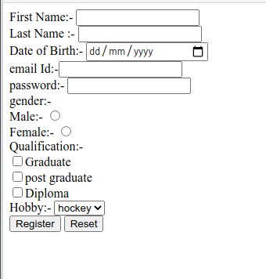

2. Create a table having student information using HTML.

Code:

<!DOCTYPE html>
<html>
<head>
<title>Student Information Table</title>
</head>
<body>
<h2>Student Information Table</h2>
<table border ="1">
<tr>
<th>Roll No.</th>
<th>Name</th>
<th>Course</th>
<th>Gender</th>
<th>Mobile</th>
<th>Address</th>
</tr>
<tr>
<td>136899</td>
<td>Aakas </td>
<td>B.Sc</td>
<td>Male</td>
<td>2579348</td>
<td>xxxxxx</td>
</tr>
<tr>
<td>136898</td>
<td>Roshan</td>
<td>BCA</td>
<td>Male</td>
<td>563289</td>
<td>xxxxxx</td>
</tr>
<tr>
<td>136897</td>
<td>Arpita</td>
<td> MCA</td>
<td>Female</td>
<td>843833</td>
<td>xxxxx</td>
</tr>
<tr>
<td>136896</td>
<td> Shyam</td>
<td>M.Sc</td>
<td>Male</td>
<td>262739</td>
<td>yyyyyy</td>
</tr>
<tr>
<td> 136895</td>
<td>Anjali</td>
<td>B.Sc</td>
<td>Female</td>
<td>528382</td>
<td>kkkkkk</td>
</table>

</tr>
</body>
</html>

Output:

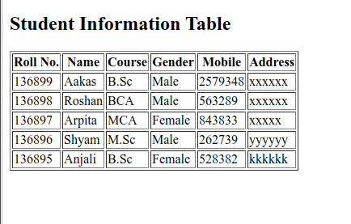

3. Explain following tags <marquee>,<sup>,<pre>,<hr>,<iframe> with respective output.
<Marquee>
The Marquee HTML tag is a non-standard HTML element which is used to scroll a image or text horizontally or vertically.
In simple words, you can say that it scrolls the image or text up, down, left or right automatically.
Marquee tag was first introduced in early versions of Microsoft's Internet Explorer. It is compared with Netscape's blink element.
Marquee HTML Example:
<marquee>This is an example of html marquee </marquee>
Attribute | Description
behavior - | It facilitates user to set the behavior of the marquee to one of the three different types: scroll, slide and alternate.
direction | defines direction for scrolling content. It may be left, right, up and down.
width | defines width of marquee in pixels or %.
height | defines height of marquee in pixels or %.
hspace | defines horizontal space in pixels around the marquee.
vspace | defines vertical space in pixels around the marquee.
scrolldelay | defines scroll delay in seconds.
scrollamount | defines scroll amount in number.
loop | defines loop for marquee content in number.
bgcolor | defines background color. It is now deprecated.
2. <sup> tag:
HTML <sup> tag is termed as a superscript tag which is used to define superscript text. The text within <sup> tag appears with an upper baseline and renders with smaller font size than surrounding text.
The <sup> tag is useful for defining Mathematical formulas and footnotes.
Syntax
<sup>......</sup>
3. HTML <pre> tag:
The HTML <pre> tag is used to specify pre-formatted texts. Texts within <pre>.......</pre> tag is displayed in a fixed-width font. Usually it is displayed in Courier font. It maintains both space and line break.
It is widely used to display language examples e.g. Java, C#, C, C++ etc because it displays the code as it is typed.
Example:
<pre>
This is a formatted text
by using the HTML pre tag. It maintains
both space and line break.
</pre>
4. HTML <hr> tag:
HTML <hr> tag is used to specify a paragraph-level thematic break in HTML document. It is used when you abruptly change your topic in your HTML document. It draw a horizontal line between them. It is also called a Horizontal Rule in HTML.
Example:
<h2>HTML</h2>
<p>HTML is a language for describing web pages. </p>
<hr/>
<h2>HR Tag </h2>
<p> HR tag is used to draw a horizontal line within the texts to sepate content. <p>
5. HTML iframes:
HTML Iframe is used to display a nested webpage (a webpage within a webpage). The HTML <iframe> tag defines an inline frame; hence it is also called as an Inline frame.
An HTML iframe embeds another document within the current HTML document in the rectangular region.
The webpage content and iframe contents can interact with each other using JavaScript.
Example:
<iframe src="https://.....com title="XYZ"></iframe>

Attribute | Value | Description
allow |  | Specifies a feature policy for the <iframe>
allowfullscreen | true  false | Set to true if the <iframe> can activate fullscreen mode by calling the requestFullscreen() method
allowpaymentrequest | true  false | Set to true if a cross-origin <iframe> should be allowed to invoke the Payment Request API
height | pixels | Specifies the height of an <iframe>. Default height is 150 pixels
name | text | Specifies the name of an <iframe>
referrerpolicy | no-referrer  no-referrer-when-downgrade  origin  origin-when-cross-origin  same-origin  strict-origin  strict-origin-when-cross-origin  unsafe-url | Specifies how much/which referrer information that will be sent when processing the iframe attributes
sandbox | allow-forms  allow-pointer-lock  allow-popups  allow-same-origin  allow-scripts  allow-top-navigation | Enables an extra set of restrictions for the content in an <iframe>
src | URL | Specifies the address of the document to embed in the <iframe>
srcdoc | HTML_code | Specifies the HTML content of the page to show in the <iframe>
width | pixels | Specifies the width of an <iframe>. Default width is 300 pixels

Code:

<!DOCTYPE html>
<html>
<head>
<title>A webpage for <marquee>,<sup>,<pre>,<hr> and <iframe> tags</title>
</head>
<body>
<h1> <marquee>This is an example of marquee tag. </marquee>
</h1>
<hr>
<h2>
<p>
We use "sup" tag for Superscripts.
5<sup>2</sup> + 3<sup>3</sup> = 52
</p>
</h2>
<hr>
<h3>
<pre> This is
an example
of preformatted tag.(pre tag)
</pre>
</h3>
<hr>
<h3>"hr" tag is used for <b> horizontal link break</b> just like above and below.
</h3>
<hr>
<h3>
This is an Example of "iframe" tag.</h3>
<iframe src="https://pranav40.github.io/" width= "80%" hight="300%" ></iframe>
<hr>
</body>
</html>

Output:

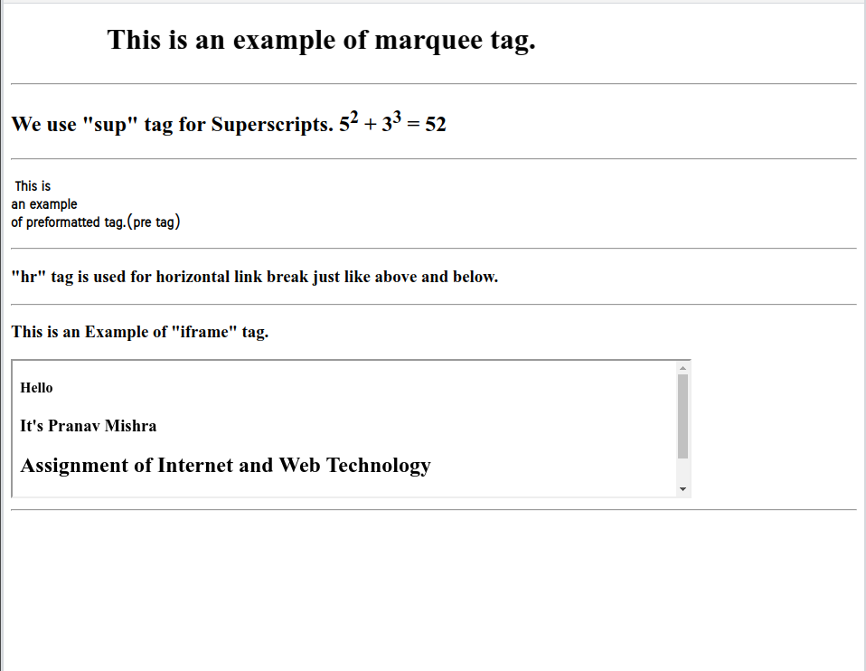

4. Design a customer registration form for online shopping.

Code:

<!DOCTYPE html>
<html>
<head>
<title>Costomer Registration Form for Online Shopping</title>
</head>
<body bgcolor="Yellow" align= center>
<h1>Create account</h1><hr>
<p>Please fill in this form to create an account.</p>
<form>
Your name:- <input type="text" name="Firstname" placeholder="Your name"><br> <br>

Shipping Address:- <input type="cols=70" "row=3" placeholder="Address"><br><br>
Email Id:-<input type="email" required name = "email" placeholder="Email"><br> <br>
Password:- <input type = "password" name = "password" placeholder="Password" minlenght="6" ><br> <br>
Confirm Password:-
<input type = "password" name="repassword" placeholder="Confirm Password" minlenght="6"><br><br>

<input type="submit" value="create account"><hr>
</form>
</body>
</html>

Output:

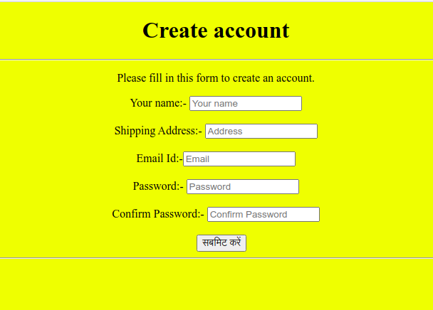

Task 5:-
<!DOCTYPE html>
<html>
<head>
<title>A a simple HTML page having multiple frames.</title>
</head>
<frameset cols="*,*">
<frame src="https://knowledgewit.wordpress.com/author/pranavdsvv/">
<frameset rows="*,*">
<frame src="https://pranav40.github.io">
<frame src="https://bca1821.github.io/UTSAV">
</frameset>
</frameset>
</html>
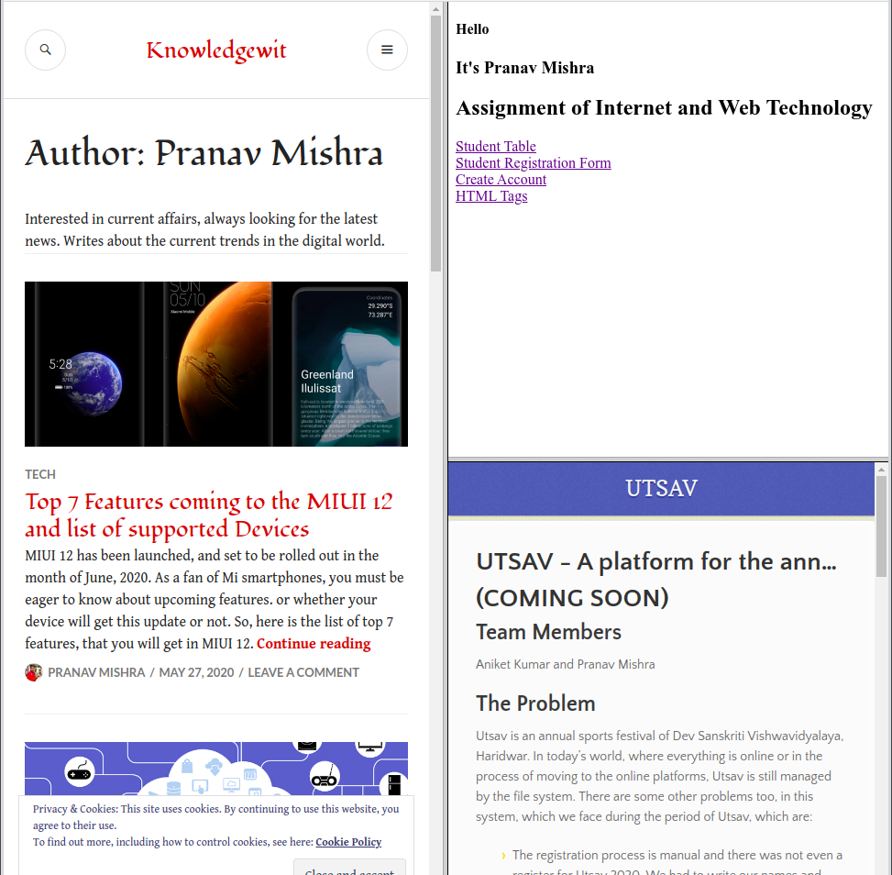
Task 6:-
<!DOCTYPE html>
<html>
<head>
<title>
Video
</title>
</head>
<body>
<video height="480" width="540" controls>
<source src="video1.mp4" type="video/mp4">
</video>
</body>
</html>


Task 7:-
<!DOCTYPE html>
<html>
<head>
<title> Inline CSS</title>
</head>
<body bgcolor ="black">
<h1 style="color:rgb(54,120,179);"> Welcome........</h1>
<p style="color:rgb(12,220,190); font-size:30px;">This page is created by using Inline CSS.</p>
</body>
</html>


Task 8:-
<!DOCTYPE html>
<html>
<head>
<title> Document (Internal level) CSS</title>
<style>
body
{ background-image: url( https://i.stack.imgur.com/vhoa0.jpg );
}
.first{
color: black;
font-size: 45px;
margin: 70px;
}
.second
{
color: black;
font-size: 25px;
margin: 90px;
}
</style>
</head>
<body>
<div class="first">
Welcome.....
<hr>
</div>
<div class="second">
<p> This page is created by using Internal CSS.</p>
</div>
</body>
</html>


Task 9:-
<!DOCTYPE html>
<html>
<head>
<title>External level CSS</title>
<link rel="stylesheet" type="text/css" href="Externalcss5.css">
</head>
<body>
<div class="first">
Welcome.....
<hr>
</div>
<div class="second">
<p> This page is created by using Internal CSS.</p>
</div>
</body>
</html>
CSS Program:-
body
{ background-image: url( https://i.stack.imgur.com/vhoa0.jpg );
}
.first
{
color: black;
font-size: 45px;
margin: 70px;
}
.second
{
color: black;
font-size: 25px;
margin: 90px;
}
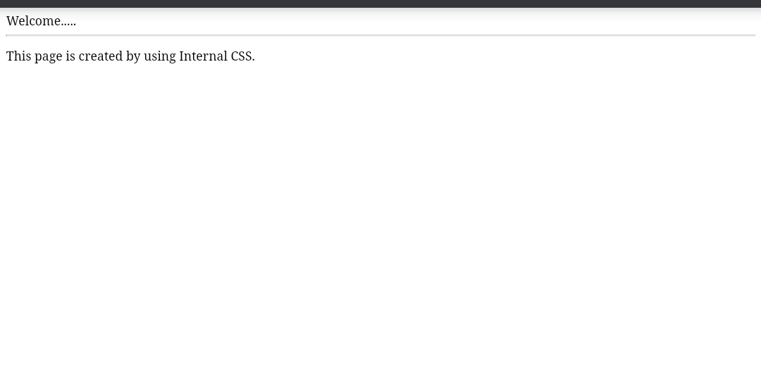
Task 10:-
<!DOCTYPE html>
<html>
<head>
<title> All CSS Font Properties</title>
<style>
body
{ background-image: url( https://i.stack.imgur.com/vhoa0.jpg );
}
.properties{
color: black;
font-size: 80px;
margin: 100px 70px;
font-variant: small-caps;
font-weight: lighter;
line-hight:250%;
}
</style>
</head>
<body>
<div class="properties">
<centre><hr><p>Successful and unsuccessful people do not vary greatly in their abilities. </p><hr></center>
</div>
</body>
</html>


Task 11:-
<!DOCTYPE html>
<html>
<head>
<title> Text Properties</title>
<style>
body
{ background-image: url( https://i.stack.imgur.com/vhoa0.jpg ); color:white;
}
h1{
text-algin: center;
text-decoration: underline;
text-transform: capitalize;
letter-spacing:3px;
line-hieght:100px;
text-shadow:2px 3px 4px white;
}
h2{
float:leaft;
margin-leaft: 50px;
word-spacing: 40px;
text-shadow: 3px 3px 3px teal;

}
</style>
</head>
<body>
<h1>"There are no shortcuts to any place worth going."</h1><hr>
<h2>Education is the most powerful weapon you can use to change the world.<hr></h2>

</body>
</html>
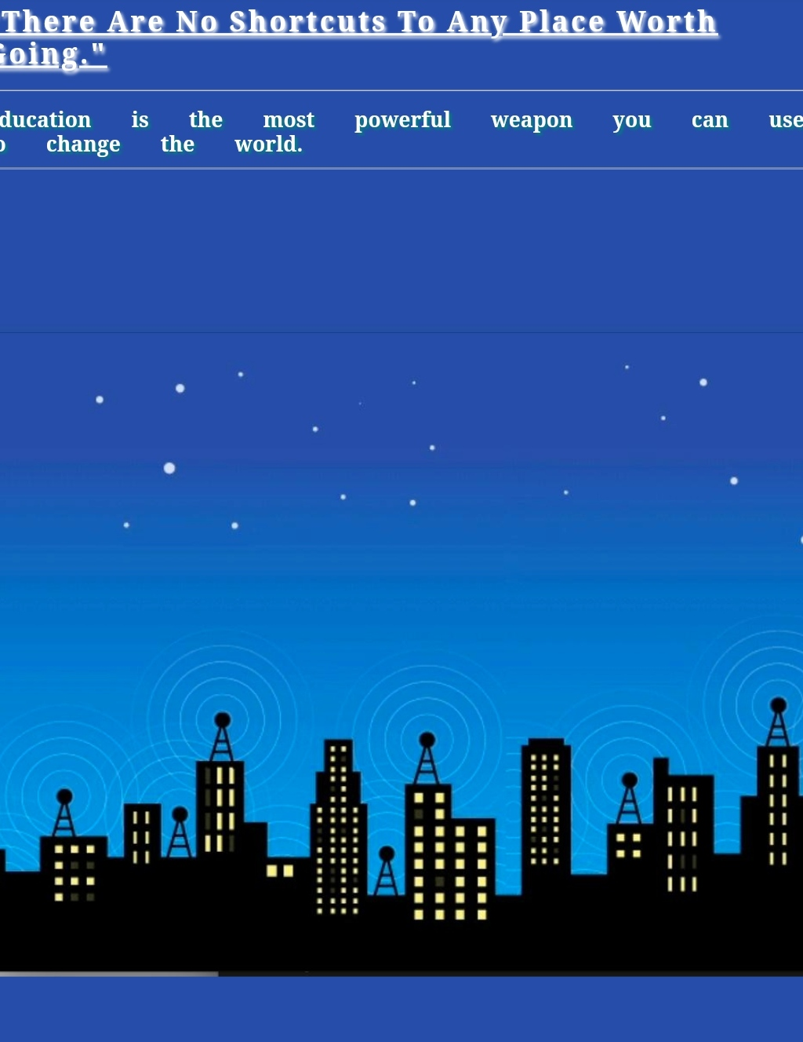

Task 12:-
<!DOCTYPE html>
<html>
<head>
<title> CSS Background Properties</title>
<style>
body
{ background-image: url(https://www.google.com/search?q=background+image+web+technology&tbm=isch&ved=2ahUKEwjo1u_3zvfrAhWikuYKHcrTCWIQ2-cCegQIABAC&oq=background+image+web+technology&gs_lcp=ChJtb2JpbGUtZ3dzLXdpei1pbWcQAzIGCAAQCBAeMgUIABDNAjIFCAAQzQI6BAgAEEM6AggAOgQIIxAnOgUIABCxAzoECCEQClCXF1jRfWCPiAFoAHAAeACAAdACiAGpL5IBBjItMTguNJgBAKABAcABAQ&sclient=mobile-gws-wiz-img&ei=MTtnX6j6LaKlmgfKp6eQBg&bih=766&biw=393&client=ms-android-xiaomi-rev1&prmd=ivsn#imgrc=u6-GuVO-RrIpGM);
background-attachment: fixed;
background-repeat: no-repeat;
background-position: centre;
}
<div>
{
color: red;
font-size: 30px;
text-align: center;
margin-top: 90px;
}
</div>
</style>
</head>
<body>
<div>
CSS Background Properties...
</div>

</body>
</html>

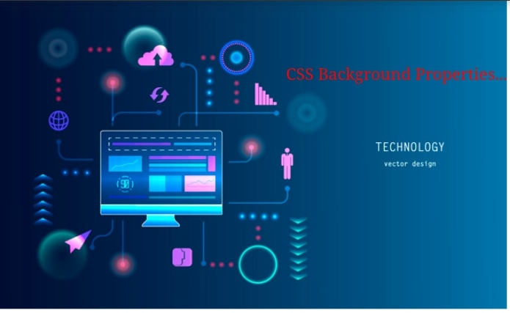

Task 13:-
<!DOCTYPE html>
<html>
<head>
<title> CSS Border Properties</title>
<style>
div
{
border: 5px double white;
border-top-style: dotted;
height: 200px;
width: 600px;
padding: 40px;
border-bottom-color: teal;
font-size: 40px;
}
</style>
</head>
<body bgcolor="skyblue">
<div>
<p> Border properties are used in this paragraph.</p>
</div>

</body>
</html>
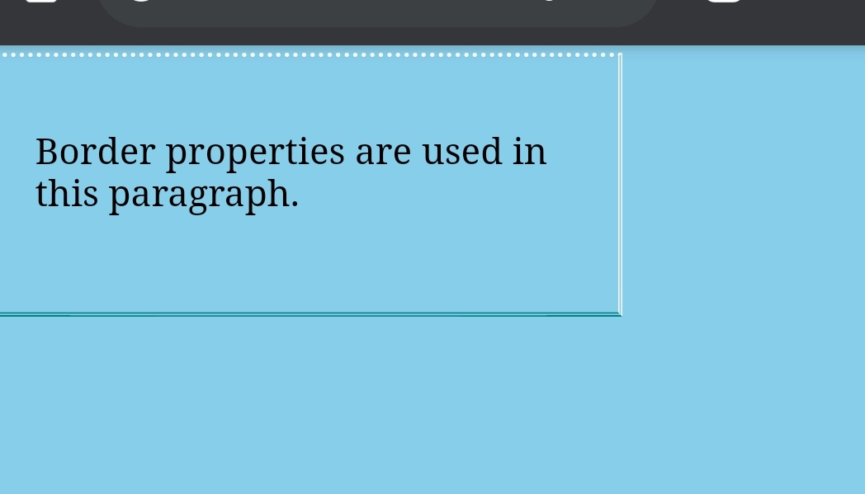
Task 14:-
<!DOCTYPE html>
<html>
<head>
<title> CSS Border Properties</title>
<style>
ul
{
list-style-type: square;
background: rgb(90 170 220);
}
ul li
{
background: rgb(166 221 208);
padding: 10px;
}
ol
{
list-style-type: lower-greek;
background: rgb(225 235 233);

}
ol li
{
background: rgb(176 221 166);
padding: 10px;
marging: 5px;
}
</style>
</head>
<body>
<div>
<ul>
<li>Unordered</li>
<li>List</li>
</ul>
<ol>
<li>Ordered</li>
<li>List</li>
</ol>
</div>
</body>
</html>
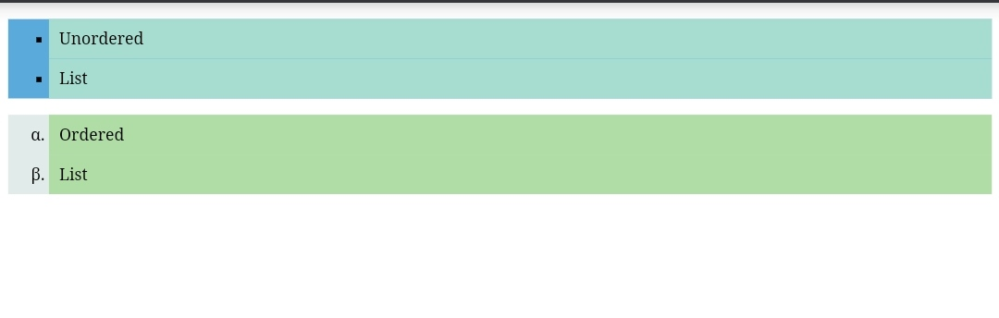

Task 15:-
<!DOCTYPE html>
<html>
<head>
<style>
tr:nth-child(even) {
background-color: white;
}
tr:nth-child(odd) {
background-color: black;
color: white;
}
th{
font-size: 20px;
}
</style>
<title>Zebra Striped Table</title>
</head>
<body>
<h4>This table contains information about
students.</h4>
<table border ="1">
<tr>
<th>Roll No.</th>
<th>Name</th>
<th>Course</th>
<th>Gender</th>
<th>Mobile</th>
<th>Address</th>
</tr>
<tr>
<td>136899</td>
<td>Aakas </td>
<td>B.Sc</td>
<td>Male</td>
<td>2579348</td>
<td>xxxxxx</td>
</tr>
<tr>
<td>136898</td>
<td>Roshan</td>
<td>BCA</td>
<td>Male</td>
<td>563289</td>
<td>xxxxxx</td>
</tr>
<tr>
<td>136897</td>
<td>Arpita</td>
<td> MCA</td>
<td>Female</td>
<td>843833</td>
<td>xxxxx</td>
</tr>
<tr>
<td>136896</td>
<td> Shyam</td>
<td>M.Sc</td>
<td>Male</td>
<td>262739</td>
<td>yyyyyy</td>
</tr>
<tr>
<td> 136895</td>
<td>Anjali</td>
<td>B.Sc</td>
<td>Female</td>
<td>528382</td>
<td>kkkkkk</td>
</table>

</body>
</html>
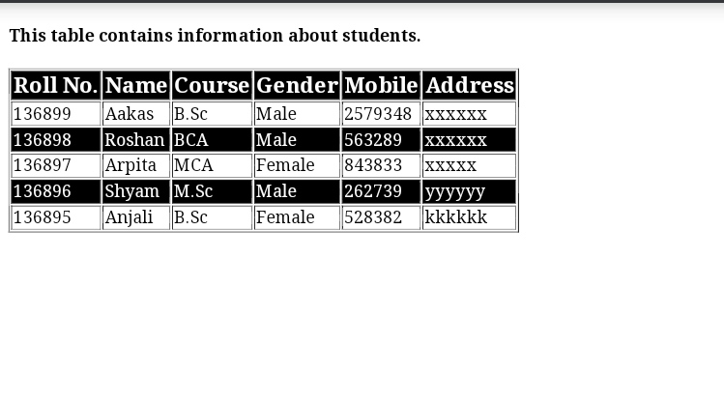
Task 16:-
<!DOCTYPE html>
<html>
<head>
<title>4 Partition Layout</title>
<style>
.row{
display: flex;
}
.column{
flex: 50%;
height: 500px;
}
</style>
</head>
<body>
<div class="row">
<div class="column" style="background-color:
aquamarine;">
<p> THE BEST WAY TO CHANGE PEOPLE IS
NOT BY RIDICULE BUT BY SHOWING THEM A NEW WAY OF THINKING AND GIVING THEM THE OPPORTUNITY TO CHANGE
</p>
</div>
<div class="column" style="background-color:
bisque;">
<p> JEALOUSY EATS AWAY AT A PERSON IN THE SAME WAY AS A MOTH EATS AWAY AT APIECE OF CLO </p>
</div>
</div>
<div class="row">
<div class="column" style="background-color:
thistle;">
<p> REALISE YOUR INDIVIDUAL SELF WORTH ANDBELIEVE THAT YOU ARE A UNIQUE ANDSIGNIFICANT PERSON IN THE WORLD.
</p>
</div>
<div class="column" style="background-color: steelblue;">
<p> WATCH YOUR THOUGHTS FOR THEY BECOMEWORDS,WATCH YOUR WORDS ,FOR THEY BECOMEACTIONS,WATCH YOUR ACTIONS FOR THEY BECOME YOURHABITS,WATCH YOUR HABITS FOR THEY BECOMECHARACTER,WATCH YOUR CHARACTER FOR IT BECOMES YOURDESTINY. </p></div>
</div>
</body>
</html>
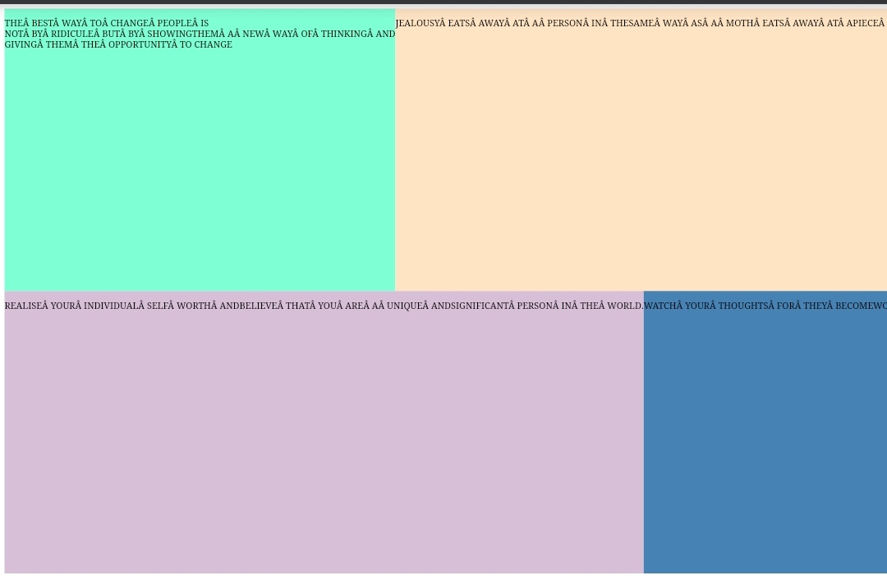

Task 17:-
<!DOCTYPE html>
<html>
<head>
<title>
Button
</title>
<style>
.btn{
background-color: blue;
color: white;
padding: 15px;
text-align: center;
font-size: 24px;
border-radius: 20%;
border: 2px solid red;
width: 200px;
}
.btn:hover{
background-color: red;
color: white;
}
.btn:active{
background-color: red;
transform: translateY(4px);
}
</style>

</head>
<body>
<button>simple button</button>
<button class="btn">CSS Button</button>
</body>
</html>

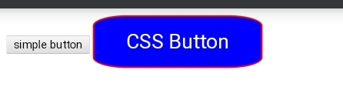
Task 18:-
<!DOCTYPE html>
<html>
<head>
<title>CSS Margin and Padding Properties</title>
<style>
h1{
border: 2px solid red;
padding-top: 50px;
padding-right: 30px;
padding-bottom: 50px;
padding-left: 80px;
margin: auto;
}
.a{
border: 1px solid green;
padding: 25px 50px 75px 100px;
margin: 25px 50px 75px 100px;
}
.b{
border: 1px solid blue;
padding: 25px 50px;
margin-top: 100px;
margin-bottom: 100px;
margin-right: 150px;
margin-left: 80px;
}
</style>

</head>
<body>
<h1>An HTML page that uses all CSS Margin and
Padding properties.</h1>
<p class="a">This is first paragraph</p>

<p class="b">This is second paragraph</p>

<p>This is third paragraph (without any CSS)</p>
</body>
</html>
